
Fleur studios

Customer Journey Marketing:
Audit Insights

Table of Contents

Why Andzen? 3
Klaviyo Attributed Revenue 4-5
List Growth 6-7
List Engagement 8-9
Data Capture 10-12
Nurture Series 13-15
Abandoned Cart 16-20
Browse Abandonment 21-24
Post-Purchase 25-31
Campaign Performance 32-33
Project Roadmap 34-35

Why Andzen?
How Andzen came to be...
Andzen started as an Email Service Provider (ESP) in London called Sign-Up.to, founded by co-founders Brenden and Matt. After selling the platform to GoDaddy, we decided to transition into a specialist agency, giving birth to ANDZEN, which now serves as our unfair advantage.

Where we are today…
We’re the first in the APAC market and fifth globally to achieve Klaviyo Elite Master Partner status - the top status an agency can be awarded by Klaviyo.

For the third year in a row, Andzen has maintained its status as a Klaviyo Elite Master Partner.
To qualify each year, an agency must meet a specific set of quantitative and qualitative criteria, which includes maintaining outstanding email health scores for all managed clients, embracing new technologies and features, and garnering a stellar reputation within the community.

What makes us so special?

We’re niche specialists and proud of that.
Unlike other agencies, we specialise in customer journeys. Our job is to assess the performance of your store at each stage of the funnel, and craft strategies to improve conversion at each point - from converting website visitors into subscribers, first-time customers into loyal brand advocates, and lapsed customers into returning customers.

We’re strategic, technical, and possess an entrepreneurial mindset.
We incorporate a host of technology partners within the Klaviyo ecosystem like Okendo, JustUno and Octane.ai among many others, to help our clients supercharge their omni-channel marketing goals. Our full team of senior creatives and technical specialists turn those strategies into beautifully-designed and highly-personalised touchpoints. We don’t (just) do pretty pictures – we reduce Customer Acquisition Costs (CAC), improve conversion rates, and grow Lifetime Value (LTV).

We embrace the Japanese concept of ‘Kaizen’ – continuous improvement.
We know what we’re good at, but acknowledge the ever-changing digital landscape. So, we make it our core mission to be an extension of the Klaviyo team and each of our tech partners, gaining early access to new capabilities and first-hand training for these advanced executions. This provides our clients with best-in-class service.

Our global presence
With teams based in Australia, the United States, and the Philippines, we extend our services to clients worldwide, spanning diverse industries. We welcome you to explore our portfolio, showcasing the remarkable outcomes we've achieved for clients across the globe. Click here
KAV: Your klaviyo total revenue [YTD]

Growth Overview: Jan. 1 - Dec. 28, 2025 Compared to Previous Period

Total Website Revenue | Total Klaviyo-Attributed Revenue | Total Flow-Attributed Revenue | Total Campaign-Attributed Revenue
$9,936,154.208  171.5% increase | $2,624,414.35  107.0% increase | $651,963.46  9.4% increase | $1,972,450.89  196% increase

Total Owned Revenue  26.41% | Owned Revenue: Flows  24.84% | Owned Revenue: Campaigns  75.16%
- Owned channels are a strong and accelerating revenue driver for Fleur Studios, generating $2.62M in Klaviyo-attributed revenue from Jan 1 to Dec 28, 2025. This represents 26.41% of total website revenue ($9.94M), placing Fleur close to Klaviyo’s ~30% owned-channel benchmark and signaling a mature, high-impact lifecycle program.
- In a year where total website revenue grew +171.5% YoY, owned revenue also scaled meaningfully at +107.0% YoY, reinforcing that email and SMS are actively contributing to growth rather than passively riding acquisition momentum.
- While owned revenue growth trails total site growth, this is not inherently negative. Instead, it reflects a business in aggressive acquisition and scale mode, where owned channels are performing reliably while acquisition channels expand rapidly. Importantly, owned revenue is still delivering nearly $1 in every $4 earned on site, positioning lifecycle as a critical stabilizer and multiplier rather than a secondary support channel.

Campaigns vs Flows
- Campaigns are the primary engine of owned-channel growth for Fleur Studios, generating $1.97M YTD and accounting for 75.16% of total Klaviyo-attributed revenue.
- Campaign-attributed revenue is up +196% YoY, significantly outpacing both total site growth and flow growth. This indicates a highly effective campaign strategy, likely driven by strong promotional moments, launches, and audience responsiveness. Fleur is successfully using campaigns to create demand, re-engage subscribers, and drive high-intent traffic back to site at scale.
- Flows generated $651.9K YTD, contributing 24.84% of owned revenue, with a more modest +9.4% YoY increase. While flows remain a meaningful revenue layer, they are under-indexing relative to the explosive growth seen in campaigns. This imbalance suggests that flows are stable but not scaling at the same velocity as top-of-funnel demand. As campaign volume and traffic increase, there is an opportunity to further optimise flow architecture, timing, and segmentation to better capitalize on the downstream intent campaigns are generating.
- In a healthy, high-growth lifecycle ecosystem, we often expect campaigns to lead during aggressive expansion phases, with flows scaling in tandem as intent volume rises. Fleur is clearly excelling at demand creation through campaigns; the next unlock lies in tightening the feedback loop between campaigns and flows. Enhancing flow structure, layering in deeper segmentation, and refining personalization would allow Fleur to capture more incremental value from the traffic campaigns are already driving.

Growing Your KAV
Strategically, Fleur Studios is operating from a position of strength. Unlike brands where owned revenue lags due to inactivity or inconsistency, Fleur’s owned channels are growing, diversified, and contributing materially to overall performance. The current opportunity is not about fixing underperformance, but about amplifying efficiency: ensuring flows fully monetise the scale campaigns are achieving.
Strengthening flow conversion and increasing their share of owned revenue can push closer to (or beyond) the 30% KAV benchmark while maintaining the momentum of its high-performing campaign engine.
In short, campaigns are powering growth, flows are stabilising revenue, and owned channels are firmly established as a scalable growth lever. With targeted flow optimisation, Fleur has a clear path to turning strong campaign-driven demand into even more predictable, compounding lifecycle revenue.

List growth

For this section, we’re focusing on your total email list to provide a comprehensive overview of your database growth dynamics YTD. This includes the Net Growth Rate, which captures the overall increase or decrease in your email list, and the Attrition Rate, which highlights the percentage of subscribers lost during a specific period (e.g., through unsubscribes, spam complaints, or email bounces).

List Growth and Net Membership Change: Jan. 1 - Dec. 28, 2025 Compared to Previous Period

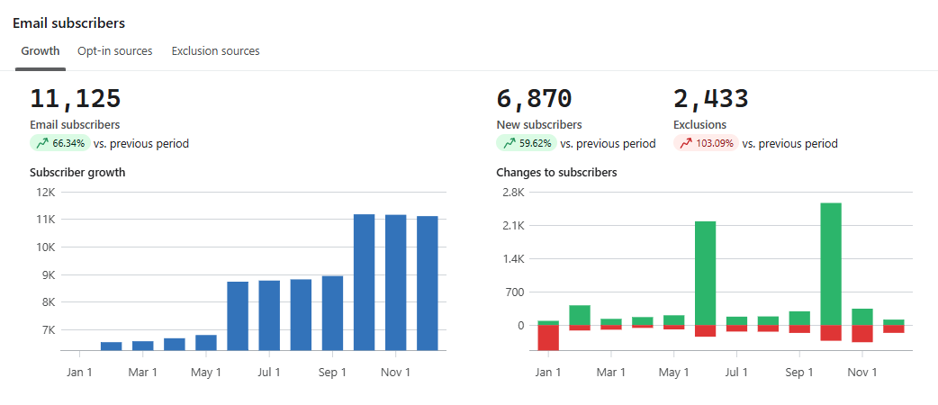

- Fleur Studios closed the period with 11,125 total email subscribers, representing a +66.34% increase vs. the previous period. This reflects strong list expansion driven by high-performing on-site acquisition, though paired with a notable rise in churn as send volume and campaign activity scaled.
- During the period, 6,870 new subscribers were added (+59.62%), while 2,433 exclusions were recorded (+103.09%), resulting in a net list gain of +4,437 subscribers. Net growth remains decisively positive, but the acceleration in exclusions indicates growing list pressure as the program matures and audience exposure increases.
- This pattern is typical of brands in a rapid growth phase: acquisition scales first, followed by a normalization period where disengaged or low-intent subscribers self-select out. Importantly, Fleur’s net growth shows that acquisition continues to materially outpace churn, preserving campaign reach expansion.

Opt-In Sources: Growth Driven by On-Site Capture
- Subscriber growth is overwhelmingly fueled by core on-site acquisition mechanisms, with one channel clearly dominating:
  - Sign-up webpage: 5,493 subscribers (+832.6%)
  - Facebook integration: 611 subscribers (+6.08%)
  - Sun Ranch Giveaway Sign-Up: 427 subscribers (>999%)
  - 2023 Flyout Form: 415 subscribers (+79.65%)
  - API subscribe: 2 subscribers
- The sign-up webpage alone accounts for the vast majority of new subscribers, validating the effectiveness of Fleur’s primary capture experience. Secondary sources, including giveaways and legacy flyout forms, contribute incremental volume but remain materially smaller.
- This concentration is not inherently risky at Fleur’s current scale, but it does highlight an opportunity to diversify acquisition with more intent-based entry points (e.g. category-specific opt-ins, launch-driven captures, or segmented incentives) to improve downstream engagement quality as list size grows.

Exclusion Drivers: Churn Rising With Scale
- Total exclusions reached 2,433, with churn largely driven by intentional subscriber actions rather than technical issues:
  - Email link unsubscribe: 1,070 (+29.85%)
  - One-click unsubscribe: 883 (+238.31%)
  - Manual suppression: 339 (>999%)
  - Hard bounce: 125 (+4.17%)
  - Spam complaint: 83 (+130.56%)
- Over 80% of exclusions are unsubscribe-led, signaling active audience curation rather than list degradation. The sharp rise in one-click unsubscribes suggests increased inbox exposure and frequency, not necessarily misalignment, but it does reinforce the importance of cadence control, engagement-based suppression, and clearer expectation-setting at opt-in.
- Spam complaints remain low in absolute terms relative to list size, though the YoY increase warrants continued monitoring as campaign volume scales.

List engagement
For the purpose of this list engagement audit, we created an “All Active Profiles” segment, which includes every contact in your Klaviyo account who can be emailed, that is, profiles that are not suppressed or bounced. However, it's important to note that being ‘emailable’ in Klaviyo doesn't necessarily mean the contact has provided explicit marketing consent, especially in regions with stricter privacy regulations.
Capturing engagement across your full list of active, non-suppressed profiles offers a more comprehensive view of your subscriber base, ensuring the engagement report reflects overall performance across all eligible recipients.
The line graph below provides a visual snapshot of your database’s engagement breakdown, showing the percentage of profiles in each engagement level over the past 30 days. Note that the engagement report only encompasses the activity of the past 30 days. As a result, we are unable to generate a report covering the entire year to date.
Fleur Studios 30-Day Email Engagement Breakdown
All Active Profiles | Very Engaged Audience | Somewhat Engaged | Barely Engaged | Not Engaged | Received No Emails
19,842 | 49.60% | 3.19% | 0.06% | 23.07% | 24.08%

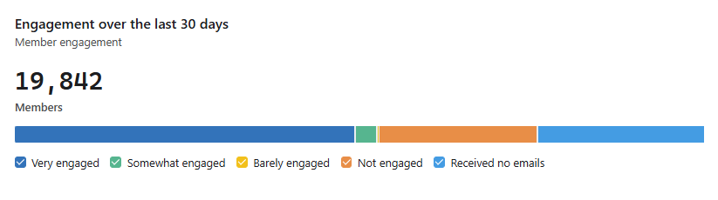
This engagement breakdown highlights how active your email list is being utilized. You will see profiles organised into 5 buckets for each of your key lists. A healthy email list should have more than 50% of members in the "Very Engaged" or "Somewhat Engaged" categories, with no more than 25% categories ed as "Not Engaged."
You will see profiles organised into 5 buckets for each of your key lists:
- Very Engaged: Recipients who have a 50%+ open rate in the past 30 days.
- Somewhat Engaged: Recipients who have a 20-50% open rate in the past 30 days.
- Barely Engaged: Recipients who have an open rate that is greater than 0%, but less than 20%in the past 30 days.
- Not Engaged: Recipients who haven't opened any emails in the past 30 days.
- Received No Emails: Recipients who haven't received any emails in the past 30 days, likely because they're suppressed, or have recently been added to the list or segment.

List Engagement Breakdown Insights

A healthy engagement distribution would have more than half of the list falling into the very engaged or somewhat engaged categories, with no more than a quarter categorised as not engaged.
In total, 52.79% of Fluer’s list falls into the Very Engaged or Somewhat Engaged categories, exceeding the healthy benchmark of 50%+ engaged profiles. This is a strong signal that Fleur’s email content, cadence, and value proposition are resonating with a majority of reachable subscribers.
At the same time, Not Engaged profiles sit at 23.07%, which remains within the acceptable ≤25% threshold. This indicates that disengagement is being kept largely under control, even as the list scales rapidly.
Overall, Fleur Studios’ engagement distribution is fundamentally healthy and above benchmark. The majority of the list is actively engaging, disengagement is contained, and inbox performance is likely benefiting from disciplined sending practices.

A Strong Signal: High Concentration of “Very Engaged” Profiles
- Nearly half of Fleur’s entire active list is classified as Very Engaged, which is notably strong for a brand at this scale. This suggests that a large portion of subscribers are opening and/or clicking consistently, reinforcing that campaigns and flows are not only being sent, but are landing well in the inbox and driving meaningful interaction.
- This level of engagement provides a solid foundation for continued campaign-led growth, more aggressive segmentation, and higher-intent monetization strategies without immediately risking deliverability.

Key Watchout: 24.08% Received No Emails

The most important area to monitor is that 24.08% of active profiles (nearly a quarter of the list) received no emails in the last 30 days. This may not be due to a lack of campaigns, but more likely the result of engagement-based sending or Smart Sending exclusions.
- While this can be a healthy safeguard, it also represents idle audience capacity. These profiles are counted as active in Klaviyo billing but are not currently contributing to engagement or revenue.

Data capture
This part of the audit will discuss insights on your data capture strategy in Klaviyo. Improving your data capture strategy will maximize your email/mobile list growth with high-performing data capture forms that turn website visitors into subscribers and ultimately drive revenue.

Fleur Studios Data Capture Form Performance: Jan. 1 - Dec. 28, 2025
Name of Form | Type | Impressions | Total Submitted | Submit Rate
2023 Flyout Form | Flyout | 127k | 461 | 0.36%
Sign up webpage | Embed | 6.7k | 489k | 1.37%

- Fleur Studios currently relies on two primary email capture mechanisms: a flyout form and an embedded sign-up form. While both contribute to list growth, their relative performance reveals an unusual pattern that warrants closer attention.
- The 2023 Flyout Form generated 127K impressions over the period but drove only 461 submissions, resulting in a 0.36% submit rate. This sits well below industry benchmarks for interruptive formats like flyouts and pop-ups (typically 3–6%), indicating that while the form is highly visible, it is not converting attention into sign-ups effectively.
- By contrast, the embedded sign-up webpage recorded just 6.7K impressions, yet delivered 489 submissions, translating to a 1.37% submit rate. While still below benchmark, this makes the embed nearly 4x more efficient than the flyout, which is not usually what we see given how passive embedded forms typically are.

Areas of Opportunity

Flyout Visibility vs. Intent
- It’s unusual for an embedded footer form to outperform a flyout on conversion rate. Inline forms require users to actively scroll or seek them out, whereas flyouts are designed to capture attention and prompt action.
- This performance gap suggests that the issue is less about the embed overperforming and more about the flyout not reaching its full potential. Two contributing factors stand out:
  - Device coverage: The flyout appears to be desktop-only, which likely excludes a large portion of Fleur’s traffic and materially limits its effectiveness.
  - Incentive and timing: A 0.36% submit rate suggests users are seeing the flyout but not finding it compelling enough to act. This points to opportunities around clearer value messaging, stronger incentives, improved timing, or refreshed creative.
- Meanwhile, users who reach the embedded form are likely already high-intent, which explains its stronger efficiency despite lower exposure.
- Overall, Fleur Studios’ current data capture performance shows strong demand to subscribe, as evidenced by the embedded form’s efficiency. The challenge and opportunity lies in ensuring the flyout is able to do the job it’s designed for.

Untapped Potential: High Exposure, Low Conversion
- The flyout’s 127K impressions represent a significant unrealised acquisition opportunity. Even a modest improvement in submit rate would meaningfully change list growth outcomes. For example, increasing the flyout from 0.36% to just 1.5% would have resulted in approximately 1,900 additional subscribers over the same period, more than 4x its current contribution.
- This makes flyout optimisation one of the highest-impact, lowest-effort levers available within the acquisition stack.

Introduce Light Profiling at Sign-Up (Trade vs. Homeowners)
- Another high-impact opportunity is to introduce light profiling during the sign-up experience, specifically distinguishing between trade customers and homeowners styling their own space. This does not need to add friction if implemented thoughtfully (e.g. a simple choice on step two).
- If your site attracts a significant number of trade visitors sourcing merchandise, consider adding a field to distinguish between trade and DTC (direct-to-consumer) customers. This distinction helps you differentiate between B2B and DTC customers. Collecting this information allows us to tag customers in Klaviyo and send personalised welcome emails tailored to their profile.
- Over time, this segmentation will support stronger lifecycle performance and higher downstream conversion, especially as the list continues to scale.

Strengthen the Hook Beyond “Join for Updates”
- The current headline (“Join for exclusive access to new collections & offers”) clearly communicates intent, but does not strongly differentiate the value of subscribing or create a compelling reason to act in the moment.
- If a direct monetary incentive is not an option, there are still high-value, brand-aligned levers Fleur can use to strengthen the opt-in proposition. These alternatives focus on access, relevance, and exclusivity rather than discounting, including:
- First access to new arrivals or limited drops
- VIP entry to private or early sales moments
- A downloadable styling guide or curated lookbook
- Behind-the-scenes content or design-led inspiration
- Positioning the opt-in around privileged access and insider value reframes the exchange from “sign up for emails” to “unlock something you can’t get elsewhere.” This tactic typically drives higher conversion rates while preserving margin and reinforcing brand equity, making it a more sustainable acquisition strategy as the list scales.

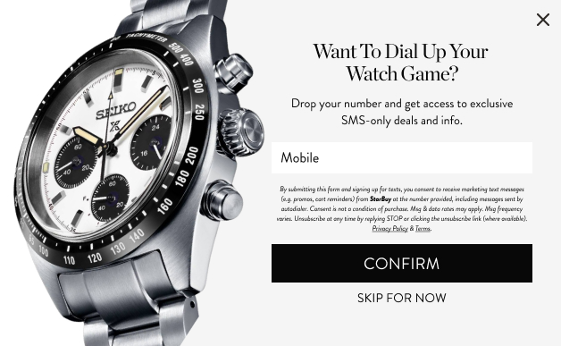
Move to a Two-Step Form Experience
Klaviyo's recent SMS consumer sentiment report indicates that over twice as many shoppers prefer to receive communications from brands through text messages rather than on social media channels.
Currently, Fleur Studios’ flyout presents email and SMS fields in a single step, which creates a higher barrier to entry at the very first interaction.

- Asking for multiple pieces of information upfront can suppress conversion, particularly on interruptive formats like flyouts where attention is limited. A two-step form reduces this friction by asking for email first (lower commitment, higher trust)
- Introducing SMS as a secondary, optional step after the initial opt-in. When collecting SMS, incorporating a multi-step process makes it more user-friendly by breaking down the form into smaller, more manageable sections, reducing the cognitive load on users, and making the process feel less overwhelming.

Welcome / nurture series
Your welcome or nurture series offers a valuable chance to connect with your leads prior to their conversion into customers. It serves as a platform to introduce them to your brand and products, establish trust, and, most importantly, guide them along the path toward making their first purchase.

With an increased volume of potential customers flowing into your funnel as a result of your data capture tactics, your onboarding process to convert these leads into customers becomes a lot more important.

In these next pages, we will be going over the performance of your flows to evaluate their identify any underperforming metrics that need attention. This allows us to pinpoint areas needing improvement and identify flows that require minimal adjustment, ensuring our efforts are focused where they're most needed to optimise your overall strategy.

Key Takeaways from Klaviyos’ 2024 Benchmarks Report for Flows
Based on the performance data of all aggregated ecommerce industries, here are two key learnings about the Nurture/Welcome Series:

- A nurture/welcome series is the second-highest converting flow overall, across all industries.

- With an average placed order rate of 2.32%, only the abandoned cart flow converts more often than a nurture/welcome series.

- The top 10% of welcome flows convert almost 5x as many people as the average.To break into this high-revenue group, ensure your welcome emails are personalised to your new customer or subscriber to push performance from the average, an already healthy 2%+ conversion, to as high as over 10%.

Klaviyo Benchmark Report for Welcome Series 2025 (Home, link to source)
The following figures are derived from Klaviyo's in-depth analysis per flow, specifically focusing on the average and top 10% performance metrics within the Home industry in 2025 for Welcome Series.
Welcome Series Performance: Jan. 1, 2025 - Dec. 28, 2025
Welcome Series Metrics | Average | Top 10% | Welcome Series - ALL TIME (Segment)
Open Rate | 52.64% | 74.44% | 61.01%
Click Rate | 5.26% | 15.95% | 4.67%
Placed Order Rate | 1.87% | 9.93% | 1.0%
Revenue |  |  | A$503,493.80

Key Insights
- Fleur Studios’ Welcome Series is performing strongly from an engagement perspective, indicating that first-touch messaging is resonating well with new subscribers and setting a solid foundation for downstream lifecycle performance.
- The series delivered an average open rate of 52.64%, which is well above typical ecommerce benchmarks and signals strong inbox placement, subject line effectiveness, and early brand interest. This is further reinforced by the all-time segment open rate of 61.01%, suggesting consistent performance over time rather than short-term spikes.
- The average click rate of 5.26% also reflects healthy engagement, especially for a welcome flow. While this sits below the Top 10% benchmark (15.95%), it is still indicative of subscribers actively exploring the brand early in their journey. This gap highlights opportunity to further sharpen CTAs, content hierarchy, and product discovery moments to capture more high-intent clicks.
- The placed order rate of 1.87% demonstrates that the Welcome Series is not only engaging but also converting. While this trails the Top 10% benchmark (9.93%), it aligns with expectations for a premium or considered-purchase brand, where conversion often happens after multiple touchpoints rather than immediately upon sign-up.

Welcome Series: Areas of Opportunity

Rebalance Revenue Contribution Beyond Email 1
- Email 1 is currently doing the vast majority of the revenue heavy lifting. Over the last 30 days, the first email generated approximately $24K in revenue, while the following four emails generated $0, with the exception of the final email contributing around $1K.
- Importantly, this is not an engagement issue - open and click rates remain strong across the subsequent emails. Instead, this may point to a relevance gap. The emails following Email 1 are structured as static, collection-led introductions (e.g. Timber Collection, Marble Guide, Stainless Steel), which may not align with each subscriber’s actual browsing intent.
- A key optimisation opportunity is to introduce behaviour-based branching within the Welcome Series. For example:
- If a subscriber browsed Stainless Steel products, they receive the Stainless Steel introduction
- If they browsed Timber, they see Timber-led content
- If no clear browsing signal exists, they receive a more general discovery or best-sellers email
- This strategy allows the Welcome Series to maintain its educational role while ensuring product exposure is highly relevant, increasing the likelihood that engagement converts into revenue.

Introduce Trade vs. DTC Segmentation Within the Flow
- Another high-impact opportunity is to segment the Welcome Series based on whether a subscriber is a trade customer or a direct-to-consumer (homeowner) shopper.
- Trade and DTC audiences have fundamentally different motivations:
- Trade customers are often focused on specifications, availability, pricing structures, and long-term partnerships
- DTC customers are typically driven by aesthetics, inspiration, guidance, and confidence in styling their own space
- Once this profile property is captured at sign-up (as recommended in the data capture section), it can be immediately activated within the Welcome Series to:
  - Tailor messaging tone and value propositions
  - Surface more relevant collections or use cases
  - Reduce friction and unsubscribe risk by avoiding generic messaging
- Personalizing early lifecycle messaging based on customer type increases relevance from day one and sets a stronger foundation for long-term engagement and conversion.

Compress the Welcome Timeline to Capitalize on Early Intent
- The current Welcome Series spans 18 days, with 4-day gaps between most emails (except between Emails 1 and 2). This pacing risks losing momentum at the most critical stage of the subscriber lifecycle.
- The first 7 days after sign-up are when intent is highest. As time passes without a purchase, conversion becomes increasingly difficult, not because the subscriber is uninterested, but because the sense of urgency and brand salience fades.
- Optimising the flow cadence by:
  - Sending emails in quicker succession during the first 5–7 days
  - Front-loading the most compelling content, social proof, and product relevance
  - Reducing downtime between touchpoints
- will help Fleur maximise the window where subscribers are most receptive and shorten the path from sign-up to first purchase.

Introduce a Dynamic, Behavior-Led Product Feed
- Incorporating a dynamic product feed within the Welcome Series would allow Fleur to surface products that are most relevant to each subscriber, reducing friction in the discovery journey and increasing the likelihood of meaningful engagement.
- Rather than showcasing static or generic collections, the feed can be configured to adapt based on real-time behavioural signals, such as products or categories a subscriber viewed during their first site visit. Reintroducing items they’ve already shown interest in, alongside closely related recommendations, keeps the experience personalized and contextually relevant.
- This strategy not only improves click efficiency by aligning content with demonstrated intent, but also supports earlier conversion by helping subscribers quickly reconnect with products they were already considering. As a result, the Welcome Series becomes less of a broad introduction and more of a guided continuation of the customer’s browsing journey.

Abandoned cart
A customer adding an item to their online shopping cart and almost completing checkout is a strong indication that they are interested in purchasing your product. But that sale doesn’t always come to fruition immediately.

A high-performing cart abandonment flow can be the difference between making the sale and losing it, whether your shopper forgot to complete their purchase, sought out options from another brand, or just didn’t have their credit card nearby.

Key Takeaways from Klaviyos’ 2025 Benchmarks Report
Based on the performance data of all aggregated ecommerce industries, here are two key learnings about the Abandoned Cart flow:

- Abandoned cart flows drive the highest RPR and average placed order rate for all flows. If you’re looking for a single flow to set up to drive revenue, you’ll find it in the abandoned cart series. There’s the least disparity between the median and top 10% of conversions. This may tell us that few abandoned cart flows diverge from the standard, and there's not a huge amount of variety. It also may signal that you can't go wrong with even a standard abandoned cart flow.

Klaviyo Benchmark Report for Abandoned Cart 2025 (Home, link to source)
The following figures are derived from Klaviyo's in-depth analysis per flow, specifically focusing on the average and top 10% performance metrics within the Home industry in 2025 for Abandoned Cart.
Abandoned Cart Performance: Jan. 1, 2025 - Dec. 28, 2025
Abandoned Cart Metrics | Average | Top 10% | SENTIENCE — Abandoned Cart Reminder
Open Rate | 52.64% | 74.44% | 74.59%
Click Rate | 5.26% | 15.95% | 3.45%
Placed Order Rate | 1.87% | 9.93% | 10.5%
Revenue |  |  | A$42,118.28

Key Insights
- Fleur Studios’ Abandoned Cart flow is performing exceptionally well at the bottom of the funnel, demonstrating strong intent capture and efficient conversion of high-value shoppers.
- The Sentience - Abandoned Cart Reminder achieved a 74.59% open rate, outperforming both the average benchmark (52.64%) and sitting in line with Top 10% benchmarks (74.44%). This indicates excellent inbox placement and relevance, which is expected for high-intent, behavior-triggered messaging but is still notable at this scale.
- The placed order rate of 10.5% meaningfully exceeds the average benchmark (1.87%) and aligns closely with Top 10% performance (9.93%). This confirms that the flow is not just driving engagement, but successfully converting shoppers who are already close to purchase, a hallmark of a well-timed and well-structured abandoned cart experience.
- The click rate of 3.45% sits below both the account average and Top 10% benchmark. However, in the context of a 10.5% placed order rate, this is not a negative signal. Instead, it suggests that many customers are returning to complete their purchase without requiring multiple on-email interactions, likely clicking once with high intent or navigating directly back to their cart. In other words, conversion efficiency is compensating for lower click volume, which is a strong outcome for a cart recovery flow.

Abandoned Cart: Areas of Opportunity

Expand Beyond a Single-Email Touchpoint
- The current Abandoned Cart experience consists of a single email, which limits its ability to fully capture recovery potential. Abandoned Cart and Abandoned Checkout flows are consistently among the highest-converting flows across ecommerce, as they target customers who have already demonstrated the strongest purchase intent by adding items to cart and progressing toward checkout.
- Introducing additional touchpoints allows us to:
- Reinforce the reminder across different moments of consideration
- Address common friction points (hesitation, distraction, reassurance)
- Capture conversions that don’t happen on the first reminder
- A multi-email structure enables a more strategic progression, such as an initial reminder, a follow-up with reassurance or social proof, and a final nudge with urgency or assistance. This approach ensures Fleur is not leaving recoverable revenue untapped due to limited follow-up.

Abandoned Cart Segmentation
- There is significant upside in introducing segmentation within the Abandoned Cart flow to tailor messaging based on customer context and intent.
  - New vs. Returning Customers
    - New customers benefit from reassurance-led content such as craftsmanship details, guarantees, delivery expectations, and social proof to overcome first-purchase hesitation.
    - Returning customers can be served more streamlined reminders that focus on ease, continuity, and familiarity, reducing friction to complete the purchase.
  - Cart Value-Based Segmentation
    - For high-value abandoned carts, especially those that remain unconverted after the initial reminder window, there is an opportunity to:
      - Trigger an internal alert or nudge to the team for personal outreach
      - Provide white-glove support that aligns with the premium nature of the purchase
    - This ensures high-consideration orders receive appropriate attention rather than being treated the same as low-risk, low-value carts.
  - Product-Level Personalization
    - Segmenting based on the specific products added to cart allows Fleur to highlight the unique craftsmanship, materials, and design story relevant to each category. Tailoring messaging to what the customer actually selected helps reinforce value and reduces decision paralysis, especially for considered purchases.

Lean Into Dynamic, Personalized Content
- High-performing abandoned cart emails are almost always highly personalized, and Fleur is well positioned to take advantage of this.
  - Dynamic content can be used to:
  - Surface the exact products left behind, along with supporting context
  - Highlight relevant benefits, materials, or use cases tied to those products
- Adapt messaging based on customer type, cart value, or browsing behavior
- Making each abandoned cart email feel like a continuation of the shopper’s journey, rather than a generic reminder, can increase both conversion efficiency and customer experience without increasing send volume.
Below are several dynamic strategies we recommend to further optimise Fleur Studios’ Abandoned Cart emails. Each is designed to reinforce confidence, elevate product value, and reduce friction at the moment of highest purchase intent.

Use Product-Specific Social Proof to Build Confidence
- For products that have strong customer feedback, we recommend dynamically displaying 5-star ratings and relevant customer reviews tied to the exact item(s) left in cart. Surfacing this social proof at the decision point helps reinforce quality, craftsmanship, and trust, particularly important for considered purchases.
- For shoppers who may still be weighing their decision, seeing how others have experienced and loved the same product can provide the reassurance needed to complete the purchase. This is especially effective for first-time buyers. Integrations with platforms like Okendo Reviews make it possible to pull in product-level ratings and testimonials seamlessly within Klaviyo.

Personalize With Dynamic Logic and Product Context
- Klaviyo’s if/else logic can be used to dynamically tailor messaging based on cart behaviour, customer type, and intent signals. For example:
  - If a customer abandoned a specific product category, the email can reinforce the unique craftsmanship, materials, or design story of that category.
  - If the basket size is small, dynamic product recommendations can introduce complementary or coordinating pieces that enhance the overall look and encourage higher order value.
- If the basket is already substantial, messaging can focus on reassurance, delivery expectations, or care details rather than upsell. This ensures the content feels intentional and relevant, rather than generic.

Added to Cart vs. Started Checkout
- Currently, Fleur Studios’ only active cart recovery flow is triggered by the Started Checkout event. While this is an important and high-performing trigger, the absence of an Added to Cart flow means Fleur is only re-engaging shoppers at the very end of the decision journey.
- These two triggers serve distinct and complementary purposes:
  - Started Checkout captures the highest-intent shoppers who have already committed time and effort to completing their purchase. Messaging at this stage should focus on removing final barriers to conversion, such as delivery reassurance, payment options, craftsmanship guarantees, or free shipping reminders.
  - Added to Cart, on the other hand, targets shoppers earlier in the funnel who may still be in evaluation mode or “wishlisting.” Re-engaging this audience allows Fleur to influence consideration before hesitation turns into drop-off.
- Introducing an Added to Cart flow would enable Fleur to recover intent earlier and increase the overall pool of shoppers who eventually progress to checkout.

Tailoring Content by Stage of Intent
Stage of Intent | Customer Mindset | Primary Objective | Recommended Content Focus
Added to Cart | Still evaluating or “wishlisting” | Re-engage interest and support consideration | - Highlight design details, materials, and craftsmanship  - Surface relevant customer reviews or ratings  - Showcase similar or complementary products to inspire confidence and discovery
Started Checkout | High intent, close to purchase | Remove final friction and drive completion | - Emphasise delivery timelines and free shipping  - Reinforce quality, warranty, or guarantees  - Highlight payment options and provide clear, simple reminders to complete checkout

Browse abandonment

Sending an email flow to those who have left your website without purchasing is a strategic way to recapture some of those potential sales. This provides a key opportunity to re-engage casual browsers and move them further down the funnel, increasing the likelihood that they will add to cart, start checkout, or complete a purchase.

Key Takeaways from Klaviyos’ 2025 Benchmarks Report
- Klaviyo’s aggregated performance data across the e-commerce industry shows that Browse Abandonment Flows rank third in terms of placed order rate. This demonstrates that even though these visitors may not have immediate intent to purchase, targeting them with a browse abandonment flow can reignite interest and drive conversions.
- Notably, browse abandonment emails achieve conversion rates that are 10 times higher than those of standard one-off campaigns.
- Additionally, Browse Abandonment flows tend to see higher click rates, suggesting that reminding visitors of the collections or products they were exploring is a powerful way to encourage them to return to the site and complete their purchase.

Klaviyo Benchmark Report for Browse Abandonment 2025 (Home, link to source)
The following figures are derived from Klaviyo's in-depth analysis per flow, specifically focusing on the average and top 10% performance metrics within the Home industry in 2025 for Browse Abandonment.

Browse Abandonment Performance: Jan. 1, 2025 - Dec. 28, 2025

Browse Abandonment Metrics | Average | Top 10% | Browse Abandonment - Seating
Open Rate | 54.10% | 69.72% | 60.0%
Click Rate | 4.74% | 11.08% | 5.71%
Placed Order Rate | 0.82% | 3.02% | 0%
Revenue |  |  | A$0

Key Insights

Fleur Studios’ Browse Abandonment flow (now set to Draft), currently has very limited data, with only 36 recipients over the entire period. As a result, the reported performance metrics should be treated as directional at best and are not statistically meaningful enough to assess true effectiveness.

The flow recorded a 60.0% open rate and 5.71% click rate, which are both respectable on the surface and sit above average benchmarks. However, with such a small audience size, these figures are highly volatile and the placed order rate of 0% (and no revenue) reflects the fact that the flow has not been operating at a scale sufficient to influence revenue outcomes.
- At present, Fleur Studios does not have any live Browse Abandonment flows, with the existing flow set to manual. This creates a gap in the lifecycle where high-intent browsing behavior is not being followed up, particularly for visitors who are actively exploring products but have not yet added items to cart.
- Browse Abandonment plays a critical mid-funnel role by re-engaging shoppers while they are still in discovery mode - before intent drops or attention shifts elsewhere. Reintroducing this flow would allow Fleur to support consideration earlier in the journey and increase the likelihood that browsers progress to cart and checkout.

Browse Abandonment: Areas of Opportunity

Segment by Product Type to Drive Relevance
- A key opportunity is to structure Browse Abandonment around product type or category, ensuring the follow-up content directly reflects what the shopper explored. For example:
- If a customer browsed a specific product type, the email can reinforce the unique qualities of that category - such as materials, finishes, or functional benefits.
- Messaging can be tailored to emphasize design intent and use cases, helping customers visualise how the piece fits into their space.
- This strategy ensures browse emails feel like a continuation of the shopping experience rather than a generic reminder.

Support Discovery With Similar Product Recommendations
- Browse Abandonment is an ideal moment to encourage continued exploration. In addition to reminding shoppers of what they viewed, the email can dynamically surface:
  - Similar or complementary products within the same category
  - Alternative styles, finishes, or materials that align with the original browse behaviour
- This helps reduce decision fatigue and keeps customers engaged, especially when the original product may require more consideration.

Layer in Dynamic, Educational Content for Special Collections
- For products that belong to special or premium collections, Browse Abandonment emails can include dynamic educational blocks that elevate understanding and perceived value.
  - Depending on the product browsed, these blocks could highlight:
    - Material sourcing and craftsmanship
    - Design philosophy or inspiration behind the collection
    - Care details or longevity considerations
- This content is particularly valuable at the browse stage, where shoppers are still forming confidence in the product and brand.

Additional Browse Abandonment Flows to Consider

Flow Type | Trigger Event | Captured Intent | How It Works | Why It’s Valuable for Fleur Studios
Viewed Collection Browse Flow | Viewed Collection | Early-stage, inspiration-led browsing | Triggers when a customer views a collection or range without interacting with a specific SKU | Allows Fleur to reinforce the design story behind a collection, showcase hero pieces, and guide customers toward bestsellers within the range, ideal for shoppers evaluating materials, finishes, or overall aesthetic.
Browse Search Flow | On-site Search Activity | High-intent, explicit interest | Triggers when a customer uses site search but doesn’t proceed to view a product or purchase | Search terms reveal exactly what the customer is looking for, enabling highly personalized follow-up that surfaces relevant products, collections, or materials aligned with their stated intent.
Site Abandonment Flow | General Site Activity | Broad, exploratory intent | Triggers when a visitor browses multiple pages without engaging with specific products or collections | Captures first-time or early-stage visitors with brand-led, discovery-focused messaging, helping Fleur stay top of mind and guide shoppers toward key collections or best-loved pieces

Post purchase
Essentially, after a customer completes a purchase, engagement shouldn't come to a halt. In fact, it's a repeat customer making another purchase significantly increases with each subsequent purchase. critical to maintain ongoing interaction with your customers, as research shows that the likelihood of

Therefore, during the post-purchase phase of a customer's journey, the primary objective should be to ensure a positive and enduring experience, fostering satisfaction and sustained engagement. Moreover, this series should serve as a guide, nudging the customer towards their next purchase.

Key Takeaways from Klaviyos’ 2025 Benchmarks Report
Based on the performance data of all aggregated ecommerce industries, here are some key learnings:

- Post-purchase flows have the highest flow open rate but lowest placed order rate. The immediate post-purchase experience is more about driving loyalty with your new customers than driving immediate purchases, though it's worth noting that the placed order rate is still higher than for email campaigns.

- In the post-purchase flow, you have your new customer’s attention. While an immediate additional purchase isn’t going to happen every time, the post-purchase flow is certainly an opportunity to frame up-sell and cross-sell messages, in a sensitive and timely manner so as not to appear pushy.

- The top 10% of performers have achieved 4 times more purchases. By showcasing a greater variety of products in your post-purchase emails, we can stimulate repeat purchases in a shorter time frame.

Klaviyo Benchmark Report for Post Purchase 2025 (Home, link to source)

Post Purchase Metrics | Average | Top 10%
Open Rate | 54.10% | 69.72%
Click Rate | 4.74% | 11.08%
Placed Order Rate | 0.82% | 3.02%
Revenue

Post-Purchase Performance: Jan. 1, 2025 - Dec. 28, 2025

Flow | Open Rate | Click Rate | Placed Order Rate | Revenue
2025 Post-Purchase Followup - Order Count Split | 70.45% | 6.81% | 0.54% | A$17,774.19
DT Shipping Update | 81.97% | 2.17% | 0.51% | A$17,941.78
SENTIENCE — Review Request | 54.86% | 2.76% | 0.1% | A$9,927.55
TRUST PILOT — Review Request | 58.32% | 2.66% | 2.66% | A$29,290.55
Positive Review - Discount Code | 97.44% | 5.13% | 10.26% | A$2,272.22
Winback Flow | 12.9% | 0.81% | 0% | A$0.00

Key Insights

- Fleur Studios has a well-established post-purchase ecosystem in place, with multiple flows supporting order confirmation, delivery updates, reviews, incentives, and winback. Overall, post-purchase messaging is performing strongly from an engagement standpoint, with open rates consistently exceeding industry averages, indicating high relevance and strong inbox placement during this phase of the customer journey.
- Across the post-purchase suite, open rates largely sit above the 54.1% benchmark, with several flows significantly outperforming the Top 10% threshold (69.7%). This confirms that customers are highly receptive to communications immediately following purchase, particularly operational and trust-building messages.
- While engagement is strong across most post-purchase flows, conversion performance is uneven and closely tied to intent and timing. Flows that are transactional or trust-led in nature (e.g. order follow-ups, shipping updates, and review requests) perform exceptionally well in opens and contribute meaningful revenue, despite relatively modest placed order rates.
- In contrast, incentive-led or re-purchase-driven flows show more mixed results. Where offers are closely aligned with customer intent and delivered at the right moment, conversion performance is strong. However, flows that attempt to drive repeat purchase without sufficient intent or urgency show weaker outcomes, suggesting that timing and segmentation are critical in this stage of the lifecycle.
- The winback-oriented post-purchase messaging currently underperforms relative to the rest of the suite, with low engagement and no attributed revenue. This is not unexpected as winback is inherently a lower-intent use case and typically performs best when triggered later in the lifecycle, once true inactivity has been established.

Post-Purchase: Areas of Opportunity

Expand Cross-Sell & Upsell Within High-Performing Post-Purchase Touchpoints

- The 2025 Post-Purchase Follow-Up – Order Count Split flow is already performing exceptionally well from an engagement perspective, with a 70.45% open rate and 6.81% click rate. These metrics indicate that customers are highly receptive to post-purchase communication at this stage, creating a strong opportunity to layer in incremental revenue without increasing send volume.
- At present, the flow is engagement-led rather than revenue-led. Introducing strategic cross-sell and upsell moments would allow Fleur to better capitalize on this attention while the brand and product are still top of mind.

Relevant Cross-Sell & Upsell Opportunities for Fleur Studios
- Cross-sell content should be tightly aligned with what the customer has already purchased, reinforcing cohesion rather than introducing friction. Examples include:
  - Material-based extensions
    - If a customer purchases a piece in marble, timber, or stainless steel, surface complementary items in the same material family to encourage collection-building and design consistency.
  - Category adjacency
    - After a purchase in one category (e.g. a table or statement piece), introduce adjacent categories that naturally complete a space, such as lighting, accents, or smaller decorative elements.
  - Styling-led bundles
    - Showcase “complete the look” suggestions that position additional pieces as part of a curated set, rather than as standalone add-ons.
  - Elevated alternatives or upgrades
    - For returning customers, introduce premium finishes, limited designs, or larger-scale pieces that build on their initial purchase.
Expanding the Post-Purchase Journey
For Fleur Studios, the post-purchase journey represents a critical extension of the customer experience. Engagement should not stop at purchase. Expanding post-purchase content allows Fleur to continue the conversation, reinforce value, and guide customers toward their next interaction with the brand.
- First-time buyers: First-time customers are still validating their decision and assessing whether Fleur Studios aligns with their expectations around quality, craftsmanship, and design.

  - Education and reassurance, highlighting materials, craftsmanship, and design intent behind the product they purchased.
  - Introducing adjacent collections or product types in a non-promotional, inspirational way.
  - Light styling guidance that helps customers envision how Fleur pieces work together within a space.
  - A friendly founder check-in email a few days after the order is received to ensure customer satisfaction will also reinforce a positive shopping experience.

- Second-time buyers: By the second purchase, customers have demonstrated confidence in Fleur’s product quality and experience. This is a key moment to deepen the relationship and encourage broader exploration of the range.

  - Content should focus on reinforcing brand loyalty and strengthening the emotional connection.
  - Reinforce brand affinity through storytelling, design philosophy, or behind-the-scenes insight.
  - Introduce complementary or adjacent product categories aligned with the customer’s prior purchase (e.g. pairing materials, finishes, or design styles).

- Repeat customers: These customers are loyal to your brand, often making purchases based on familiarity and trust. They’re likely drawn to your brand’s aesthetic and quality, returning because your products fit their needs and preferences. For this group:
- Highly tailored product recommendations based on prior purchases and materials or styles already owned.
- Invitations to engage more deeply with the brand through reviews or feedback, where advocacy is strongest
- Occasional “surprise and delight” moments, such as personalised thank-you notes or exclusive access, to reinforce loyalty.

Leveraging Profit Peak to Strengthen Retention & Lifecycle Strategy
- Fleur Studios is already integrated with Profit Peak, providing a strong measurement foundation. The opportunity now lies in more fully embedding Profit Peak into the post-purchase ecosystem. Even when immediate optimisation isn’t possible, maintaining consistent tracking is critical. Without it, long-term retention patterns and performance drivers become difficult to assess retrospectively.
- Profit Peak also plays a critical role in retention reporting, allowing Fleur to:
- Measure the true impact of post-purchase flows on repeat purchase rate
- Understand which customer cohorts are driving long-term value
- Separate acquisition-driven growth from retention-led growth
- This insight is especially valuable as Fleur continues to scale its post-purchase suite. Rather than adding more journeys, Profit Peak enables the team to focus on what actually drives incremental lifetime value.

Strengthening Retention Accuracy with Profit Peak

For brands with smaller or segmented traffic volumes, accurately identifying returning customers becomes increasingly important and challenging. When returning visitor identification is inconsistent, post-purchase journeys can lose precision over time, impacting both customer experience and lifecycle effectiveness.

Without reliable recognition of repeat behaviour:
- Returning customers may be re-treated as first-time buyers
- Post-purchase flows can feel misaligned or repetitive
- Lifecycle logic becomes progressively less accurate as the customer base scales
- Profit Peak helps mitigate these challenges by providing a stronger customer-level tracking layer that improves how repeat behavior is captured and interpreted, even when identity resolution is not perfect. For Fleur Studios, this is particularly valuable in the post-purchase phase, where understanding whether a customer is progressing toward repeat purchase, stalling, or beginning to lapse directly informs how and when re-engagement should occur.

Segmenting Based on Customer Type: Trade or DTC

Another high-impact segmentation opportunity within post-purchase is distinguishing between trade and direct-to-consumer customers. This can be implemented either through branching logic within existing post-purchase flows or via a dedicated trade-specific journey, allowing Fleur to tailor messaging, timing, and value propositions to the distinct needs of each audience.

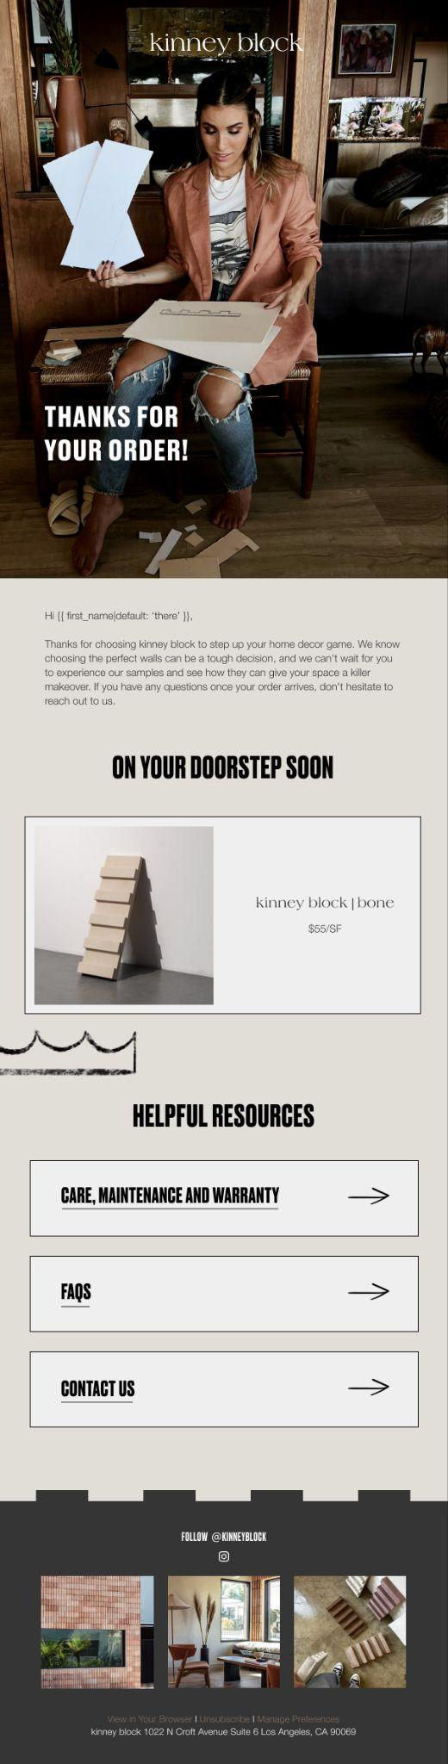
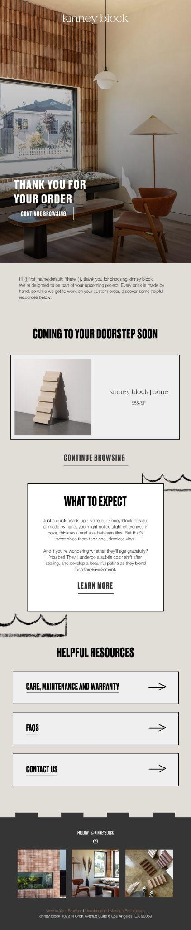

Example: In this example, we created a separate Customer Thank You email for trade customers, expressing our excitement to be part of their company project.

Meanwhile, the email for homeowners conveyed enthusiasm to help beautify the customer’s home. This tailored messaging enhances the customer experience by making it more relevant and personal.

Lapsed Customer Winback Flow
Triggered by “Predicted Date of Next Order”

Klaviyo’s Predicted Date of Next Order feature gives us the ability to predict when your customers will complete their next order. By using this as a trigger, we are targeting customers around the time they are most likely to buy with you again.

Although the Post Purchase flow triggers after an order is placed, ideally after it's been fulfilled, we find it more suitable to utilise the Predicted Date of Next Order for a lapsed flow. By our definition, a "lapsed customer" can be identified as someone who has not repurchased after going through the Post Purchase flow and the lapsed flow is an ongoing engagement automation for customers who have become inactive after a set period.

Within this journey, potential content ideas could involve introducing lapsed customers to new products, upselling and cross-selling between products, as well as offering a maximum discount to prompt action from those already displaying disinterest, as long as the discount aligns comfortably within your margins.

campaign performance YTD
We’ve reviewed year-to-date campaign performance to understand how campaigns are tracking against key engagement and revenue metrics. The analysis below highlights average performance across the period and benchmarks it against industry standards to identify strengths and opportunities.

Campaigns Performance Summary: YTD
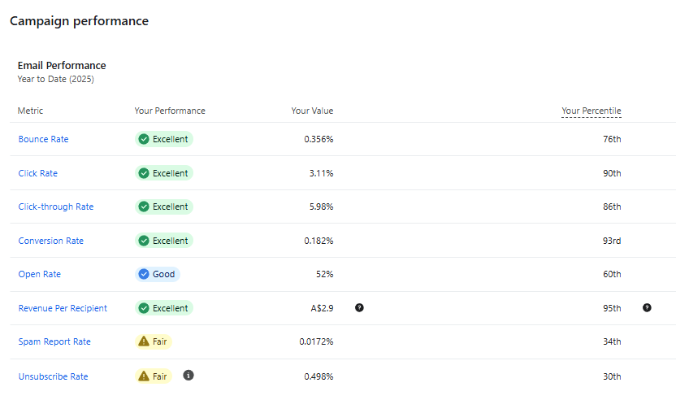

Key Insights
- With campaigns averaging three sends per week and targeted primarily to 210-day and 365-day engaged segments, Fleur is prioritizing inbox health and relevance over volume, and the results reflect that choice.
- Across key engagement metrics, Fleur consistently ranks in the top quartile to top decile:
  - Click Rate: 3.11% (90th percentile)
  - Click-Through Rate: 5.98% (86th percentile)
  - Conversion Rate: 0.182% (93rd percentile)
  - Revenue Per Recipient: A$2.90 (95th percentile)
- These results indicate that when Fleur sends, subscribers are not just opening and clicking - they are buying. The exceptionally high revenue per recipient is especially notable and suggests strong offer alignment, product relevance, and effective post-click experience.
- The open rate of 52% (60th percentile) is solid rather than standout, but this is not a concern in context. With longer-window engaged segments (210–365 days), open rate normalization is expected, and the downstream metrics confirm that opens are translating into meaningful action.

Deliverability & List Health
- Inbox health remains strong:
  - Bounce rate: 0.356% (76th percentile)
  - Spam report rate: 0.0172% (34th percentile)
- While spam and unsubscribe rates are flagged as “fair,” both remain within acceptable thresholds, particularly given the longer engagement windows being used. This suggests that Fleur is pushing reach without materially compromising deliverability, a difficult balance to strike, and one they are managing well.
- The unsubscribe rate of 0.498% (30th percentile) is slightly elevated relative to engagement metrics, but not unexpected given the use of broader engaged segments and consistent weekly sending. Importantly, this appears to be controlled attrition rather than a signal of misaligned content.

Segmentation Strategy: Conservative, But Effective
- Alternating between 210-day and 365-day engaged segments is a conservative segmentation strategy that prioritizes scale while maintaining engagement quality. This strategy is clearly working from a performance standpoint, as evidenced by strong conversion and revenue efficiency.
- However, this also suggests headroom for expansion. With such strong efficiency metrics and a relatively light send cadence, Fleur likely has room to:
- Introduce tighter engagement tiers for high-intent moments
- Test incremental sends to highly engaged cohorts
- Layer in campaign variants without risking inbox health

Klaviyo project proposal for fleur studios
Deliverable | Outline
Onboarding  Client Meetings &  Account Management Consulting | - Kick-off meeting  - 1 Hours monthly reporting meeting + 30 minute mid-month WIP meeting  - 2 hours per month Consulting / Troubleshooting time
Reporting | - Monthly reporting of Data-Capture, Flow and Campaign Performance  - Insights and recommendations for forms, campaigns and automation  - List and segment growth reporting
Multi-Step Data Capture Popup (Keep original strategy but revamp design and add SMS collection) | - Creative for 3 x Data Capture Forms  - Build of 3 x Data Capture Forms  - 3 x QA checks post forms launch (1 day, 1 week & 1 month)
Nurture Flow | - Strategy for 5 x emails and 1 x SMS  - Creative for 5 x additional emails  - Setup of automation workflow in Klaviyo  - Build of 5 x email and 1 x SMS  - 3 x QA checks post flow launch
Abandoned Checkout (Started Checkout) | - Strategy for 4 x email and 1 x SMS  - Creative for 4 x email and 1 x SMS  - Setup of automation workflow in Klaviyo  - Build of 4 x email and 1 x SMS  - 3 x QA checks post flow launch
Added to Cart Flow | - Strategy for 3 x email and 1 x SMS  - Creative for 3 x email and 1 x SMS  - Setup of automation workflow in Klaviyo  - Build of 3 x email and 1 x SMS  - 3 x QA checks post flow launch
Browse Abandonment (Viewed Product) | - Strategy for 4 x emails  - Creative for 4 x emails  - Setup of automation workflow in Klaviyo  - Build of 4 x emails  - 3 x QA checks post flow launch
Browse Abandonment (Viewed Collection) | - Strategy for 3 x email and 1 x SMS  - Creative for 3 x email and 1 x SMS  - Setup of automation workflow in Klaviyo  - Build of 3 x email and 1 x SMS  - 3 x QA checks post flow launch
Post Purchase Flow - Thank You + Cross-Sell | - Strategy for 6 x email and 1 x SMS  - Creative for 6 x email and 1 x SMS  - Setup of automation workflow in Klaviyo  - Build of 6 x email and 1 x SMS  - 3 x QA checks post flow launch
Customer Winback Flow | - Strategy for 3 x email and 1 x SMS  - Creative for 3 x email and 1 x SMS  - Setup of automation workflow in Klaviyo  - Build of 3 x email and 1 x SMS  - 3 x QA checks post flow launch

